**Unique 제약**

1. **Create Table sample632(**

**A integer unique,**

**B integer);**

1. **Desc sample632;**
2. **Insert into sample632 values(1,1);**
3. **Insert into sample632 values(null,null);**
4. **Insert into sample632 values(1,null);**

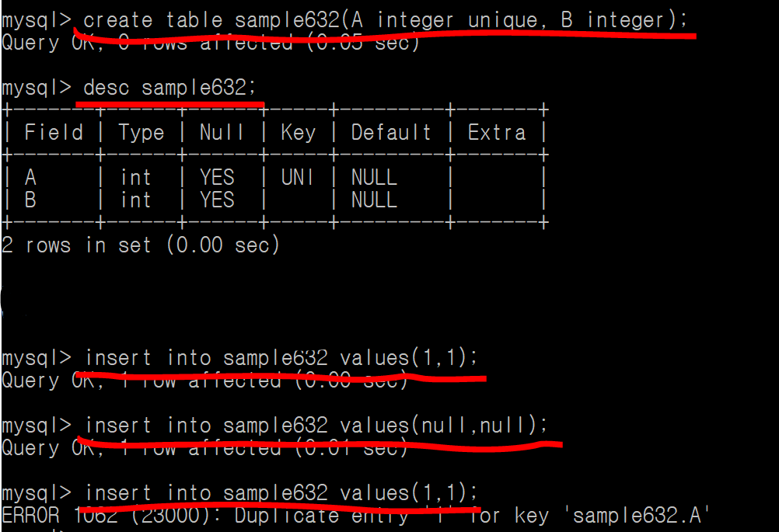

**unique 제약 🡪 중복된 값을 저장하지 못함!**